# GST 102: Spatial Analysis

## Lab 4 - Vector Data Analysis - Overlay Techniques

### Objective - Understanding Basic Vector Analysis Using Overlays

Document Version: 9/10/2014

**FOSS4G Lab Author:** Kurt Menke, GISP  
Bird's Eye View GIS

**Original Lab Content Author:** Kurt Menke, GISP  
Bird's Eye View GIS

Copyright © National Information Security, Geospatial Technologies Consortium (NISGTC)

The development of this document is funded by the Department of Labor (DOL) Trade Adjustment Assistance Community College and Career Training (TAACCCT) Grant No. TC-22525-11-60-A-48; The National Information Security, Geospatial Technologies Consortium (NISGTC) is an entity of Collin College of Texas, Bellevue College of Washington, Bunker Hill Community College of Massachusetts, Del Mar College of Texas, Moraine Valley Community College of Illinois, Rio Salado College of Arizona, and Salt Lake Community College of Utah. This work is licensed under the Creative Commons Attribution 3.0 Unported License. To view a copy of this license, visit http://creativecommons.org/licenses/by/3.0/ or send a letter to Creative Commons, 444 Castro Street, Suite 900, Mountain View, California, 94041, USA.

This document was original modified from its original form by Kurt Menke and continues to be modified and improved by generous public contributions.

### 1 Introduction

In this lab, you will be learn about several powerful vector analysis tools. The tools are all considered overlay tools, since they produce outputs defined by how features overlap one another. You will be working with several datasets covering the Sierra National Forest in California. This lab includes the following tasks:

* Task 1 Clip
* Task 2 Intersection
* Task 3 Union
* Task 4 Join Attributes by location

### 2 Objective: Understanding Basic Vector Analysis Using Overlays

The objective of this lab is for the student to understand basic use of vector overlays in a geospatial analysis.

Vector Overlays – A set of tools, which work on the spatial relationships between two input datasets. The output is a new dataset derived from those spatial relationships.

Clip – Outputs the features of the input dataset that are within the features of the clip dataset. It is commonly used to cut datasets to the study area boundary.

Intersection – Takes two polygon datasets and outputs the areas common to both.

Union – A topological overlay of two polygon datasets, the output preserves the features that fall within the spatial extent of either input dataset.

Join Attributes by Location – Also known as a spatial join, this operation appends the attribute columns of one data set to another, based on the geographic intersection of the two datasets.

### 3 How Best to Use Video Walk Through with this Lab

To aid in your completion of this lab, each lab task has an associated video that demonstrates how to complete the task. The intent of these videos is to help you move forward if you become stuck on a step in a task, or you wish to visually see every step required to complete the tasks.

We recommend that you do not watch the videos before you attempt the tasks. The reasoning for this is that while you are learning the software and searching for buttons, menus, etc…, you will better remember where these items are and, perhaps, discover other features along the way. With that being said, please use the videos in the way that will best facilitate your learning and successful completion of this lab.

### Task 1 Clip

This lab focuses on the Sierra National Forest in California. Datasets include: the National Forest boundary, Ranger Districts, and habitat data for both spotted owl and Southwest willow flycatcher. In this first task, you will be clipping data to the study area. The spotted owl is listed as Threatened and the southwest willow flycatcher is listed as endangered by the U.S. Fish and Wildlife Service.

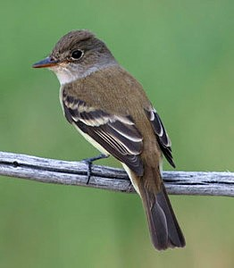

Southwest Willow Flycatcher

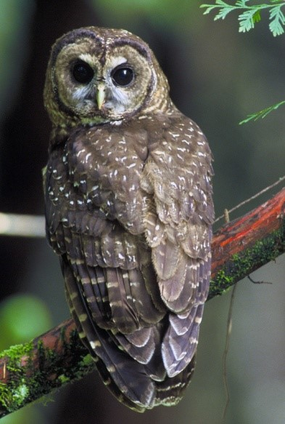

Spotted Owl

1. Open QGIS Desktop 2.2.0
2. Add both the Sierra_Natl_Forest.shp and CA_Spotted_Owl_HmRngCore.shp shapefiles to QGIS Desktop. Move the Sierra National Forest layer below the spotted owl layer.

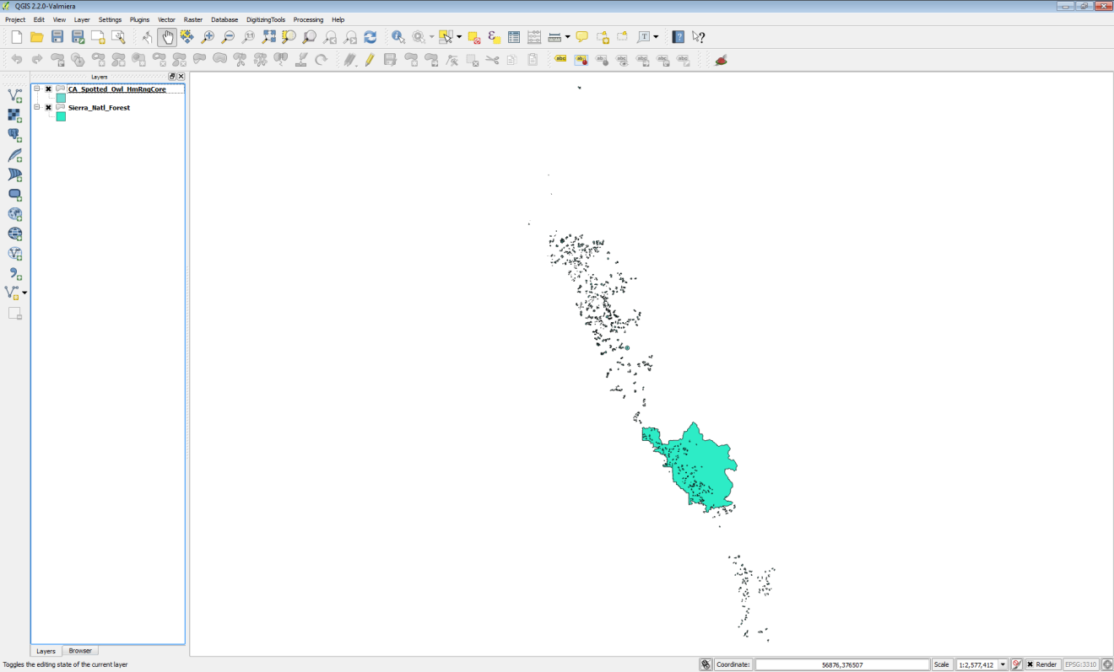

Sierra National Forest and Spotted Owl data in QGIS

In this case, you are only interested in the data covering the Sierra National Forest. Notice that the spotted owl data covers far more territory than the forest. Therefore, you will clip the spotted owl data to the forest boundary. Clip will create a new shapefile consisting of the spotted owl polygons within the forest boundary. It is standard protocol to clip datasets to the extent of the study area. This reduces data to only that which needs to be processed, and makes processing and rendering faster.

1. Before conducting a spatial analysis, you need to ensure that all the involved layers are in the same coordinate reference system. Open the Layer Properties for each layer, and identify the coordinate reference system.

**Question # 1 – Are both layers in the same coordinate reference system? What is the coordinate reference system of each layer?**

1. From the menu bar choose Vector -> Geoprocessing Tools -> Clip
   1. Input vector layer = CA_Spotted_Owl_HmRngCore
   2. Clip layer = Sierra_Natl_Forest
   3. Output shapefile = Lab 4/Data/MyData/Sierra_Spotted_owl.shp
   4. Check Add result to canvas
   5. Click OK
   6. Click Close
2. The new layer will appear in the Table of Contents. Remove the original CA_Spotted_Owl_HmRngCore layer. It was an intermediate dataset.
3. Right click on the Sierra_Natl_Forest layer and choose Zoom to layer extent. Your map should now resemble the figure below. Unlike selecting by location and exporting the selected set to a new layer, the Clip operation actually cuts spotted owl polygons at the forest boundary where they crossed the forest boundary.

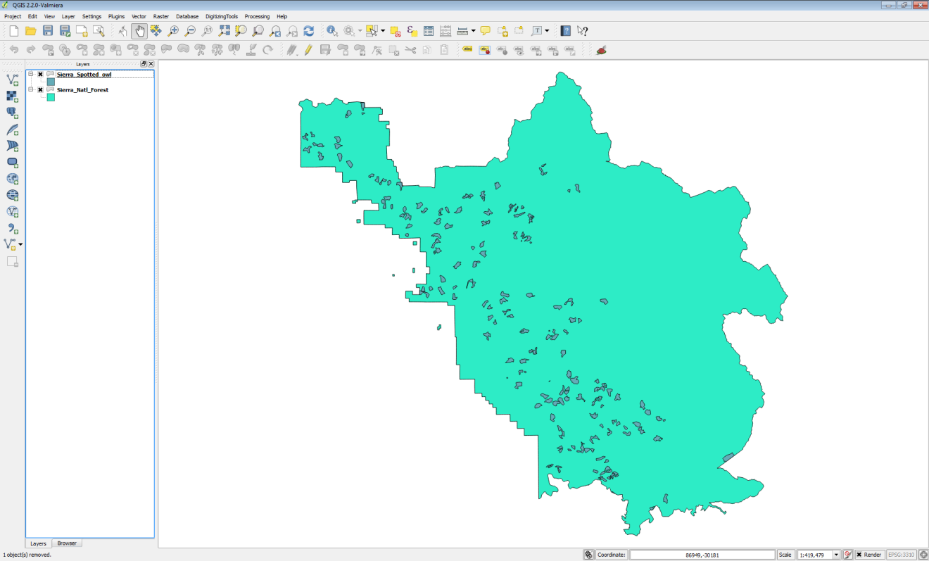

Spotted Owl Data Clipped to the Forest Boundary

1. Save the project as Lab 4.qgs

### Task 2 Intersection

You will now include the southwest willow flycatcher habitat data in the analysis.

1. Open QGIS Desktop 2.2.0 and open Lab 4/Data/Lab 4.qgs if it is not already.
2. Add Sierra_WillowFlycatcher shapefile to QGIS Desktop. This data set falls completely within the forest boundary so there is no need to clip it.
3. Spend a few minutes styling your data.
   1. Give the National forest a light green color.
   2. Give the spotted owl habitat an orange fill.
   3. Give the Southwest willow flycatcher habitat a red fill and outline.
4. Your map should now resemble the figure below.
5. Use the Zoom in tool Zoom in tool to drag a box and zoom in to the area outlined in black in Figure 3.

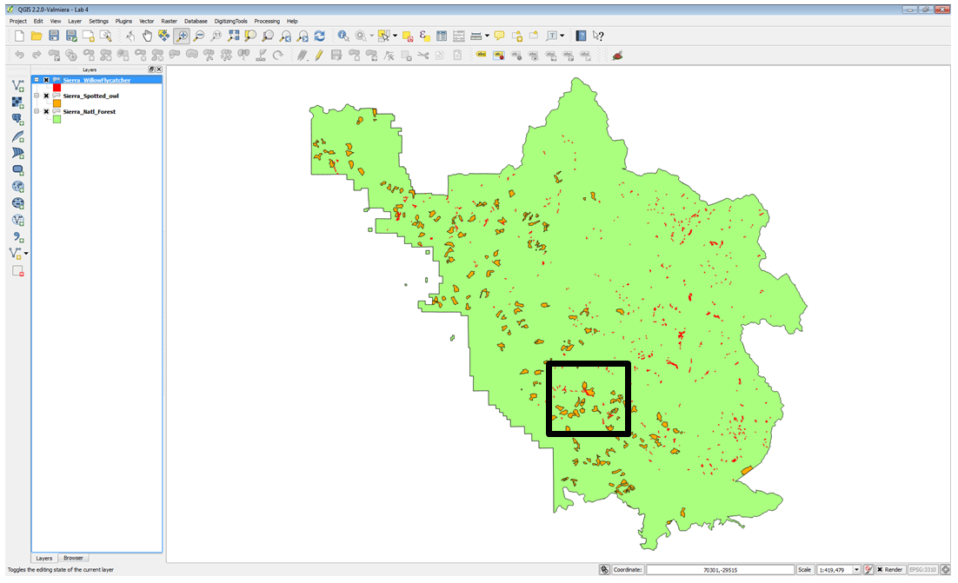

Overlap areas

You will notice that in this area, there is some overlap between the Southwest willow flycatcher and spotted owl habitat (figure below). Since these are both sensitive species, areas of habitat overlap will be important areas to protect. You could certainly conduct a spatial query to select Southwest willow flycatcher polygons that overlap spotted owl polygons. However, here you will see the value of using the Intersect tool to identify these overlapping areas.

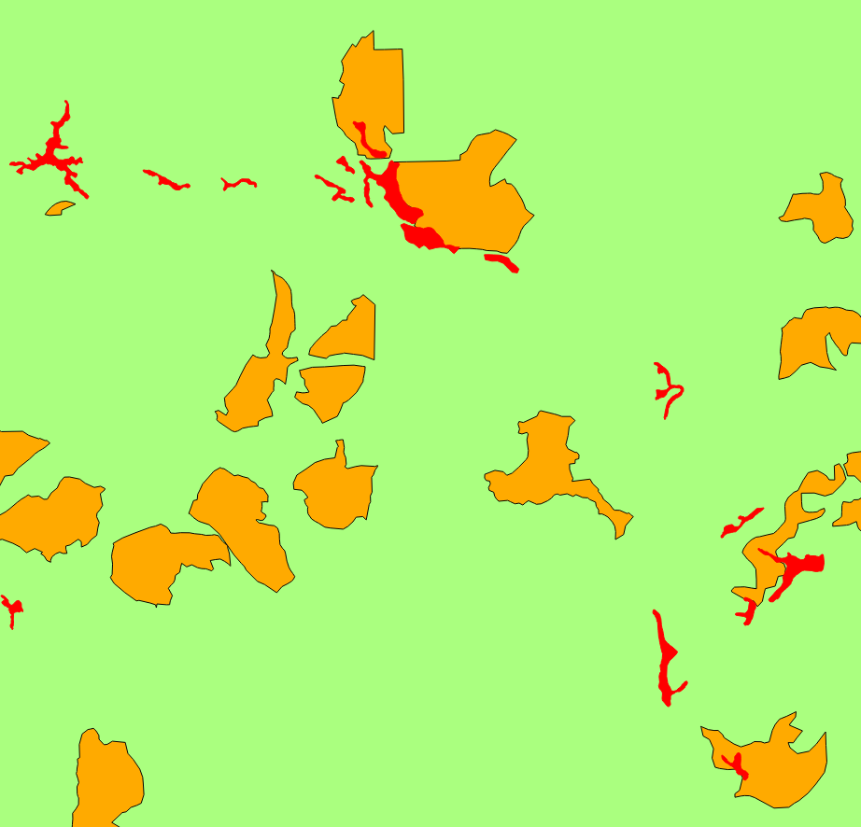

Overlap areas

1. From the menu bar choose Vector -> Geoprocessing Tools -> Intersect. Fill out the form as in the figure below.

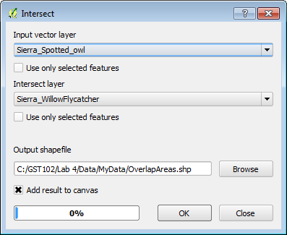

Intersect tool

1. When finished Click Ok and then click Close.
2. Style the OverlapAreas with a bright yellow Fill and Border. Your map should now resemble the figure below.

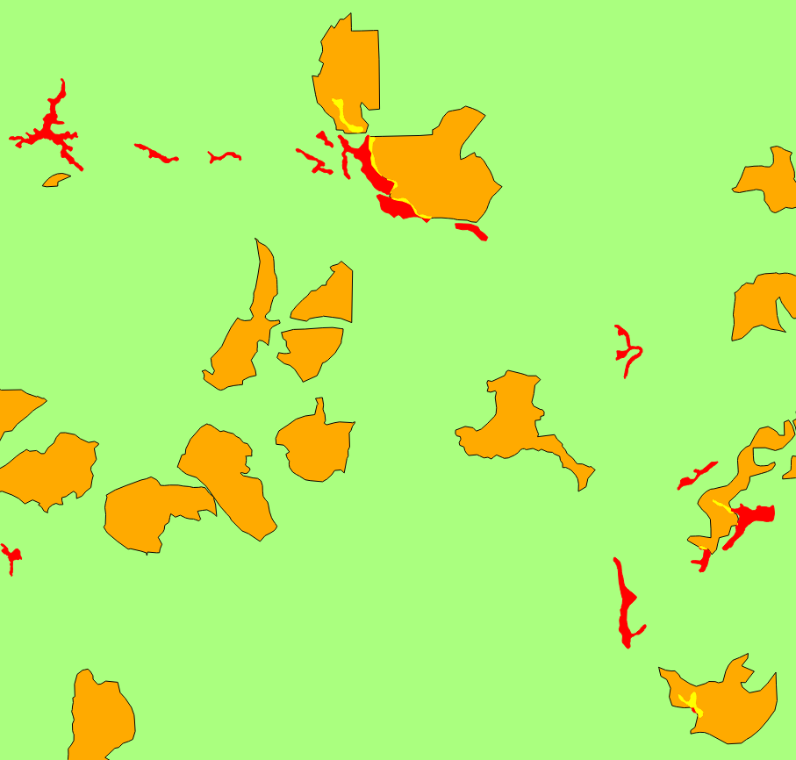

Areas of Habitat Overlap

1. Save your map.

### Task 3 Union

You will now combine both habitat layers in different ways using both the Union and Dissolve tools. Union creates a new GIS layer that combines all the geometries of both input layers. Dissolve merges all coincident polygons together.

1. Open QGIS Desktop 2.2.0 and open Lab 4/Data/Lab 4.qgs if it is not already.
2. From the menu bar, choose Vector -> Geoprocessing Tools -> Union. Fill out the Union window as in Figure 7 below.
3. When finished Click Ok and then click Close.

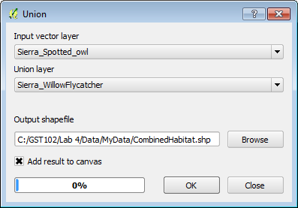

Union tool

1. The output contains all the polygons from both layers (figure below). In addition, all the polygons retain their original attributes! Overlapping areas receive attributes from the Union layer (Sierra_WillowFlycatcher).

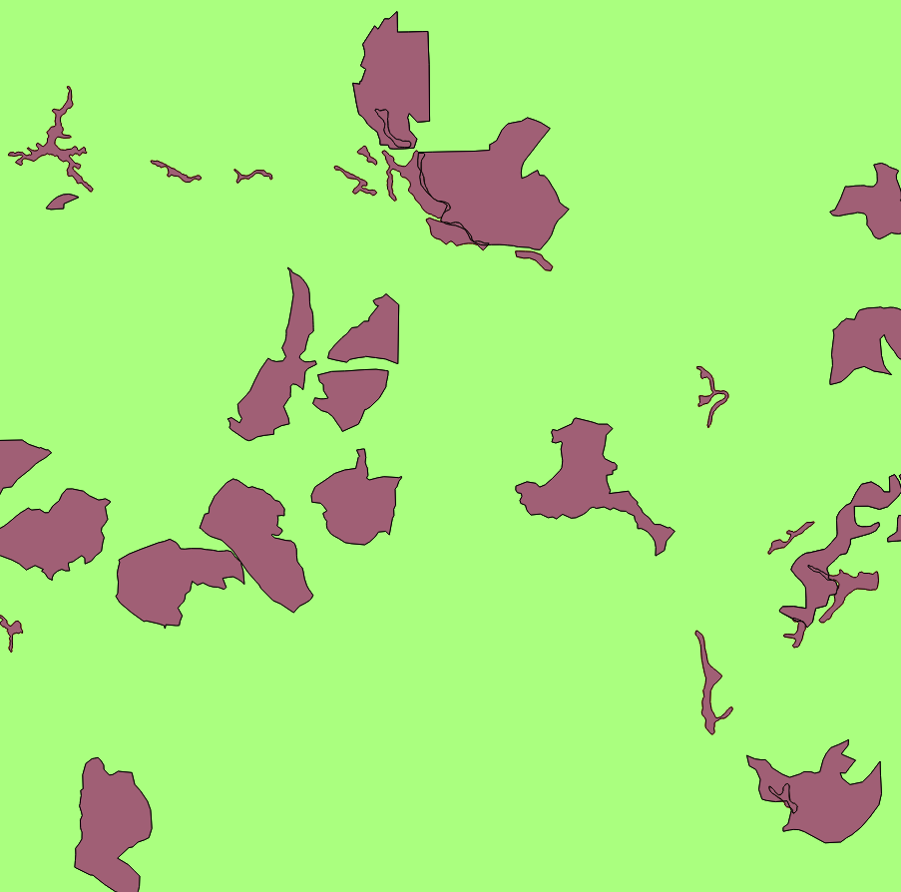

Union Output

Now you will Dissolve all the polygons into one contiguous polygon layer representing areas of habitat for both species.

1. From the menu bar, choose Vector -> Geoprocessing Tools -> Dissolve. Fill out the Dissolve window as in Figure 9 below.
2. When finished Click Ok and then click Close.

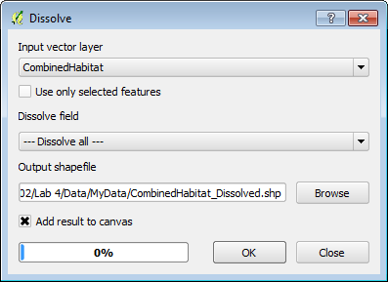

Dissolve tool

1. The figure below shows the output of the Dissolve operation.

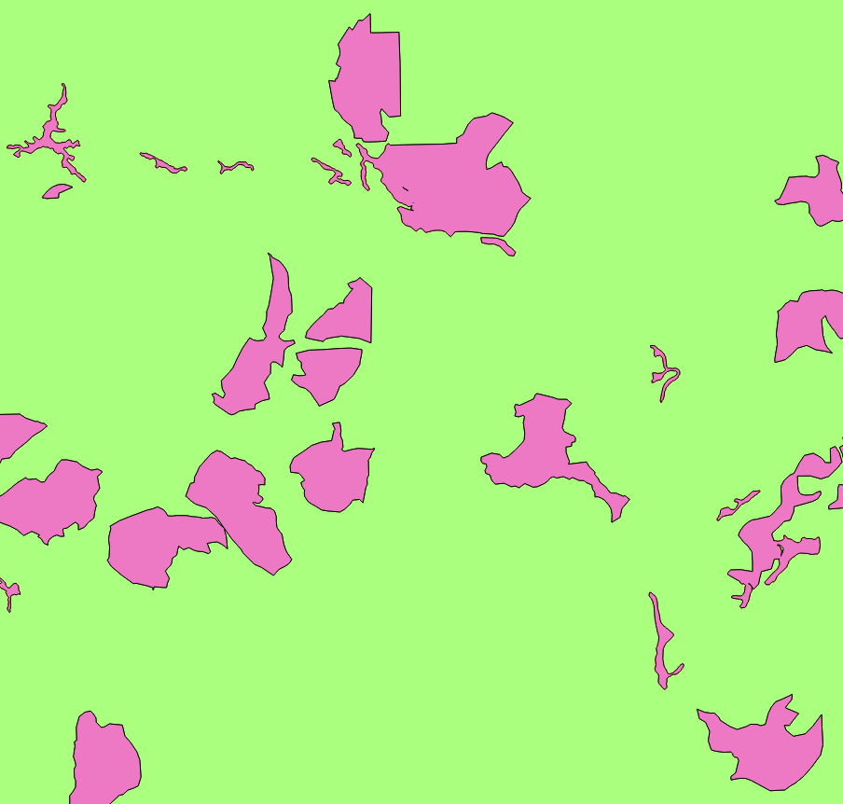

Dissolve Output

1. Save your map.

### Task 4 Join Attributes by Location

In this final task, you will incorporate the Ranger District shapefile into the analysis. There are three Ranger Districts in the Sierra National Forest. You will determine the Ranger District that each spotted owl habitat polygon is situated in. To do this you will conduct a spatial join. Unlike an attribute join done in Lab 3, a spatial join appends attributes from one layer to another based on the location. This will allow you to attach the attributes from the Ranger District layer onto the spotted owl layer.

1. Open QGIS Desktop 2.2.0 and open Lab 4/Data/Lab 4.qgs if it is not already.
2. Add the Sierra_Ranger_Dist shapefile to QGIS Desktop.

Remember that data layers need to be in the same coordinate reference system when conducting a geoprocessing operation between layers.

1. Open the Layer Properties for the Ranger District layer.

**Question # 2 – What is the coordinate reference system of the Ranger District layer?**

1. Since it is in a different coordinate reference system than the other datasets, you will first have to save it to a new coordinate reference system. Right click on Sierra_Ranger_Dist and choose Save as…
2. Fill out the Save vector layer as… form as shown in the figure below. You can find the output coordinate reference system by searching on the EPSG code for CA Albers: 3310.

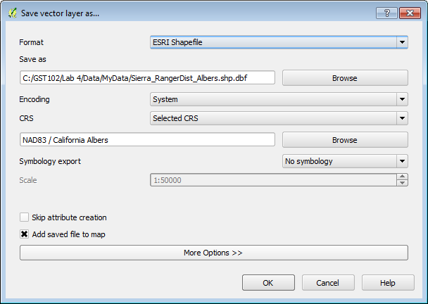

Save Vector Layer as...

1. Once the layer has been re-projected, Remove the original Ranger District layer from QGIS Desktop.
2. Style the new Albers Ranger District layer with a Fill of No Brush and a Border of dark green (figure below).

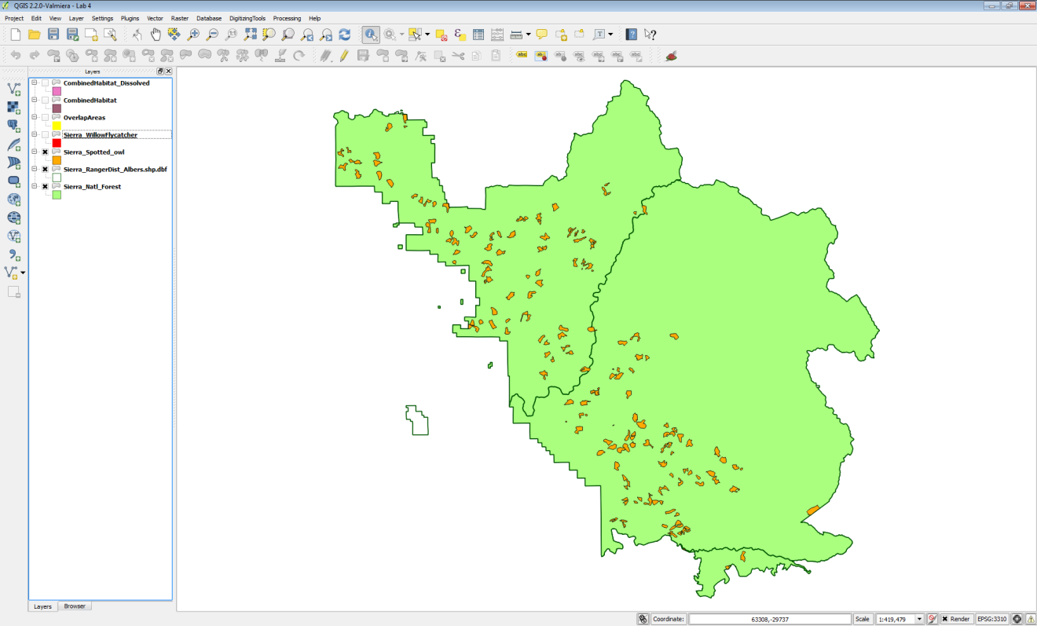

Albers Ranger Districts Layer Added to Map and Styled

1. Now you are ready to conduct the spatial join. From the menu bar, choose Vector -> Data Management -> Join attributes by location. Fill out the form as in the figure below below. The output will be in the form of a new spotted owl habitat shapefile with Ranger District attributes appended.

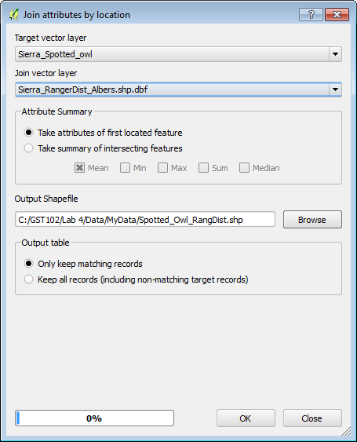

Spatial Join Tool

1. Click OK to perform the join. When finished confirm that you want the layer added to the map. Click Close.
2. Select the Spotted_Owl_RangDist layer in the Table of Contents by clicking on it once. Now use the Identify tool Identify tool to query the individual polygons of the Spotted_Owl_RangDist shapefile. You will see the additional Ranger District attribute columns added.
3. Save your project.

### 5 Conclusion

In this lab, you explored the use of vector overlay tools with habitat data in the Sierra National Forest. There are many similar overlay tools, which when used in combination, allow you to parse the spatial relationships of multiple data layers. These tools allow you to extract data and turn it into information by narrowing down the area of interest.

### 6 Discussion Questions

1. Describe the Clip operation.
2. Describe the Intersect operation.
3. How do Intersect and Clip compare in their output?
4. Before you run an overlay tool, what aspect of your input spatial data layers should you inspect, to ensure it is the same for all?

### 7 Challenge Assignment

The Southwest willow flycatcher data also covers multiple Ranger Districts. Conduct a spatial join between the Southwest willow flycatcher data and the Ranger districts as you did with spotted owl in Task 4. Compose a map that shows the both the spotted owl and Southwest willow flycatcher data styled by the Ranger District they are situated in.